Sound:

Two boundary microphones, preferably cardioid pattern, to be put on the floor.

One small omni microphone to be put under the TV set. Could be a wireless headset (with just the soft cable), a lavalier, etc. The important thing is that it's small enough to be hidden under the TV.

A handheld wireless vocal microphone.

Sound comes from PC 3.5 jack output.

Two monitor speakers

A generic vocal effect for reverb/delay, in the mixing board or separate.

----------------

Video for the TV:

TV min 42inch

Video comes from the computer via VGA . computer should be close to a mixing board.

SET:

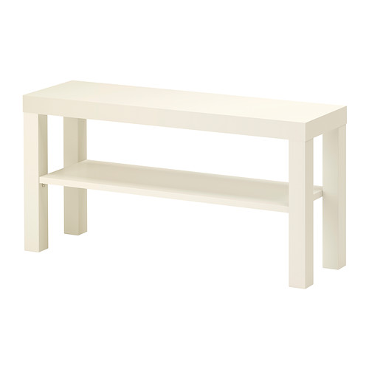
One ikea white TV table –
Ikea model Number:
502.432.99

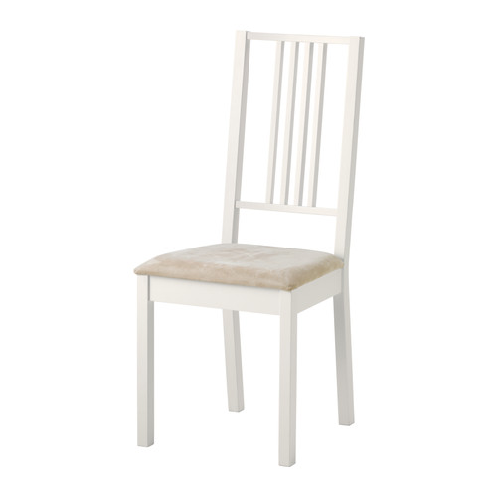

Onw white Ikea chair Borje

Ikea Article Number:
902.115.31

Donload PDF template 10 card

http://ivodimchev.com/Icure_card_pdf.pdf

Everyone person in the audience must be have a printed card and a pen or pencil

white dance floor

